Output the NAME of the COLUMN N

List in order according to the parameters that are met below.

Working with two (2) separate EXCEL WORKBOOK SPEADSHEET.

If a condition cannot be met the script to list the output and record what condition is not met.

The output will be in:

3 month- 6-month -9 month- 12-month 18-month and 24-month periods from the date in

COLUMN A and COLUMN U.



The objective of the script is to find and list in order the Name in Column N where the conditions below are met.

At Column E the script is to run for each number from 1 to the highest number in the column separately outputting the data.

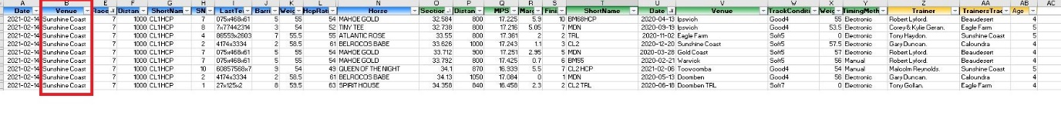

The script is to run for each Name in column B.

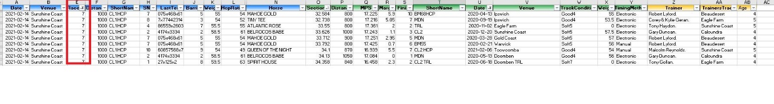

Column Q - Find the highest value.

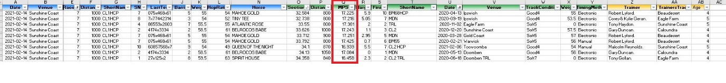

And If

Column I has an (x) in the right-hand side of the string of numbers.

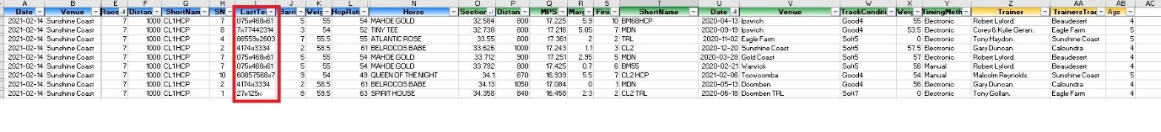

And If

Column I has an (x and one number to the right of it exists) 

And if

Column F value is between 850-1300

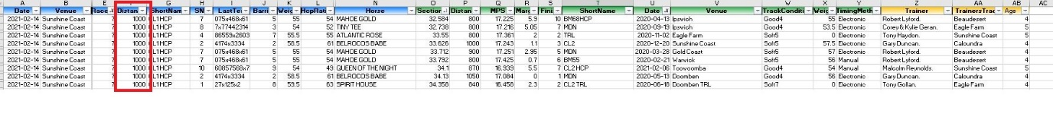

And if

Column J is lower number (1-2-3-4-5) more favourable.

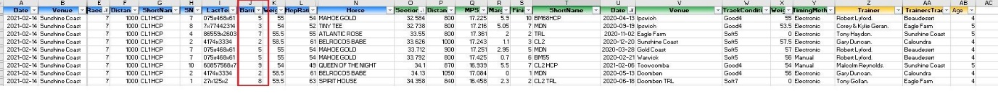

And if

Column W the value is <=58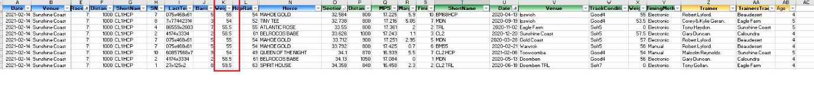

And if

Column O value is between 31.00 - 33.99 to be recorded the lower is better.

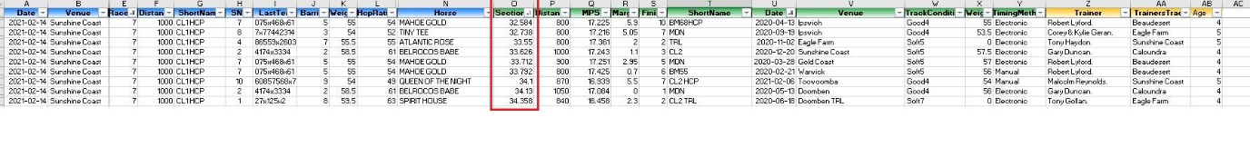

And if

Column T name is recorded as (G1-G2-G3-LISTED)

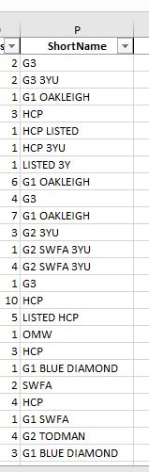

And if

Column AA is equal to column B.

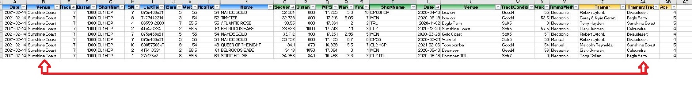

And if

COLUMN T for the most recent date COLUMN U is lower in COLUMN G to be highlighted.

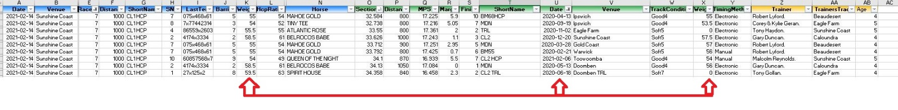

The script should run a routine that uses the above requirements using the

F COLUMN AND P COLUMN only and output the name in COLUMN N

